

MID TERM REPORT

ON

**Smart Home**

**Submittedby: SubmittedTo:**

Pranshu gupta (171500228) Dr. Manoj varsheney

Vishal singh(171500387)

Punya prakash Sharma(171500244)

Himanshu Sharma(171500137)

Course: B.tech

Branch: CSE

**ABSTRACT**

Smart home automation system is web based application that allow user to monitor home application using mobile device. This system is established for entire home user after gaining access to administrator. This system include remote control and monitoring domestic application,security. Once all the application in home are connected, it is important to consider the issue of security authentication and access control. The goal of project is to create a IOT smart home that can monitor specific area and monitor specific devices.

**INTRODUCTION**

While the cost of living is going up, there is a growing focus to involve technology to lower thoseprices. With this in mind the Smart Home project allows the user to build and maintain a house that is smart enough to keep energy levels down while providing more automated applications. A smart home will take advantage of its environment and allow seamless control whether the user is present or away. With a home that has this advantage, you can know that your home is performing at its best in energy performance. A low cost and efficient smart home system is presented here. This system has two main modules: the hardware interface module and the software communication module. At the heart of this system is the Arduino UNO microcontroller which is also capable of functioning as a micro web server and the interface for all the hardware modules. All communication and controls in this system pass through the microcontroller. The smart home system offers feature such as environmental monitoring using the temperature, humidity, gas and smoke sensors. It also offers switching functionalities to control lighting ,fans/air conditioners, and other home appliances connected to the relay system. Another feature of this system is the intrusion detection which it offers using the motion sensor and all these can be controlled from the Android Smartphone app.

**EXISTING SYSTEM**

The Existing system based on with the GSM Module & Bluetooth Module only. The recent developments in technology which permit the Use of Bluetooth and Wi-Fi have enabled different devices to have capabilities of connecting with each other. In this system we can control our all electronic equipments through our cell phone but this system does not has the smart sence.We can produce the smart sence by using various sensors.

**PROPOSED SYSTEM**

Our proposed system is a NodeMCUbased home automation done with NodeMCU controlled via android app. This system deals with the safety in home and smart home technologies which will a be cost efficient. Arduino can sense the surroundings by receiving input signal from a variety of sensors and can affect its environment via actuators. The Passive Infra-Red (PIR) sensors allow one to sense motion, almost always and are used to detect whether a human has moved in orout of the sensors range. The PIR sensor is a pyroelectric device thatdetects motion by measuring changes in the infrared level emitted bysurrounding objects.

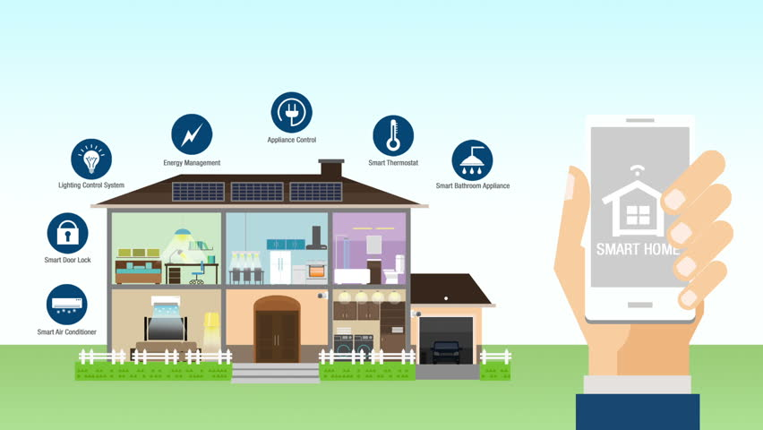

USES OF THE PROJECT

1. [Heating,ventilationandairconditioning](https://en.wikipedia.org/wiki/HVAC):itispossibletohaveremotecontrolofall[homeenergy monitors](https://en.wikipedia.org/wiki/Home_energy_monitor)overtheinternetincorporatingasimpleandfriendlyuserinterface.
2. [Lightingcontrolsystem](https://en.wikipedia.org/wiki/Lighting_control_system):wecancontrolourlightsbyusingourcellphone.
3. Automatic warning system when anyone tries to enter in the home without admin’s permission.
4. Counts no. of persons entered in the house.

FUNCTIONAL SPECIFICATION

1. We can control our all lights through using our android cell phone.
2. It will give you the count of persons entered in the room
3. Rain detection system
4. Smart security system

SOFTWARE SPECIFICATION

1. Technology Implemented:IoT
2. Language Used: Embedded C
3. User Interface: Android Application

HARDWARE REQUIREMENTS

1. NodeMCU
2. Connecting wires
3. Power source
4. Resisters
5. Bread Board
6. PIR sensor
7. Rain sensor
8. RGB lights
9. Servo moters
10. Temperature Sensor

**HARDWARE DESCRIPTION**

1. **NODEMCU:**

NodeMCU is an open-source firmware and development kit that helps you to prototype or build IoT product. It includes firmware which runs on the ESP8266 Wi-Fi SoC from Espressif Systems, and hardware which is based on the ESP-12 module.

The firmware uses the Lua scripting language. It is based on the eLua project, and built on the Espressif Non-OS SDK for ESP8266.

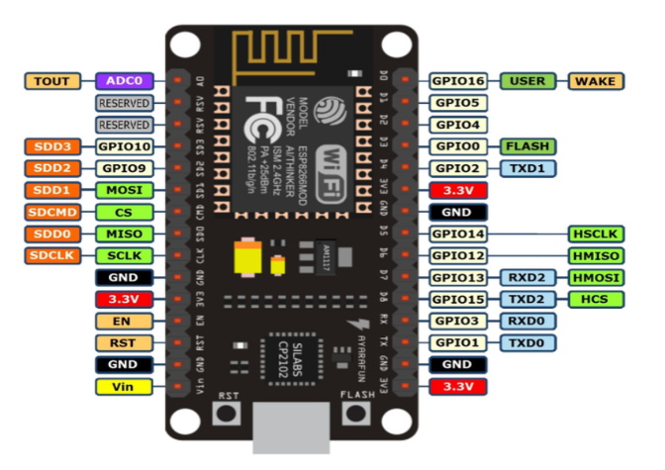

**2. PIR SENSOR:**

A passive infrared sensor (PIR sensor) is an electronic [sensor](https://en.wikipedia.org/wiki/Sensor) that measures [infrared](https://en.wikipedia.org/wiki/Infrared) (IR) light radiating from objects in its field of view. They are most often used in PIR-based [motion detectors](https://en.wikipedia.org/wiki/Motion_detector). PIR sensors are commonly used in security alarms and automatic lighting applications. PIR sensors detect general movement, but do not give information on who or what moved.

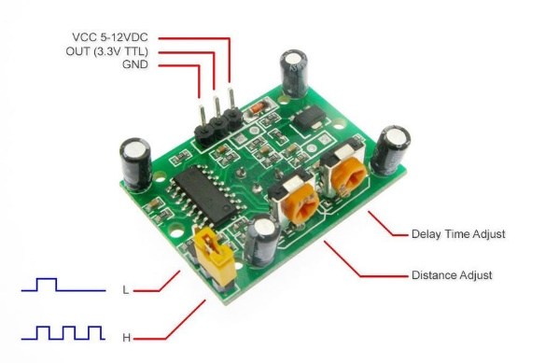

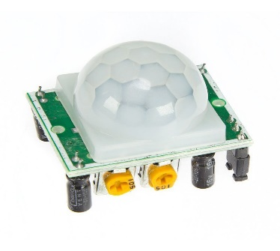

**3. RAIN SENSOR:**

A rain sensor or rain switch is a switching device activated by rainfall. There are two main applications for rain sensors. The first is a [water conservation](https://en.wikipedia.org/wiki/Water_conservation) device connected to an automatic [irrigation](https://en.wikipedia.org/wiki/Irrigation) system that causes the system to shut down in the event of rainfall. The second is a device used to protect the interior of an automobile from rain and to support the automatic mode of [windscreen wipers](https://en.wikipedia.org/wiki/Windscreen_wipers).

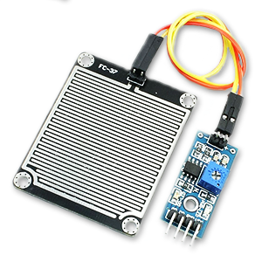

1. **TEMPERATURE SENSOR:**

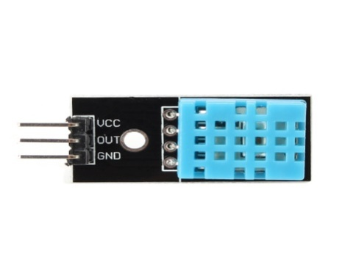The DHT11 is a basic, low-cost digital temperature and humidity sensor. It uses a capacitive humidity sensor and a thermistor to measure the surrounding air, and spits out a digital signal on the data pin (no analog input pins needed). It’s fairly simple to use, but requires careful timing to grab data. The only real downside of this sensor is you can only get new data from it once every 2 seconds, so when using our library, sensor readings can be up to 2 seconds old.

1. **SERVO MOTER:**

A servomotor is a [rotary actuator](https://en.wikipedia.org/wiki/Rotary_actuator) or [linear actuator](https://en.wikipedia.org/wiki/Linear_actuator) that allows for precise control of angular or linear position, velocity and acceleration.It consists of a suitable motor coupled to a sensor for position feedback.

1. **RGB LIGHTS:**

In this [red](https://en.wikipedia.org/wiki/Red), [green](https://en.wikipedia.org/wiki/Green) and [blue](https://en.wikipedia.org/wiki/Blue) light are added together in various ways to reproduce a broad array of [colors](https://en.wikipedia.org/wiki/Color). This namecomes from the initials of the three [additive primary colors](https://en.wikipedia.org/wiki/Additive_primary_colors), red, green, and blue.

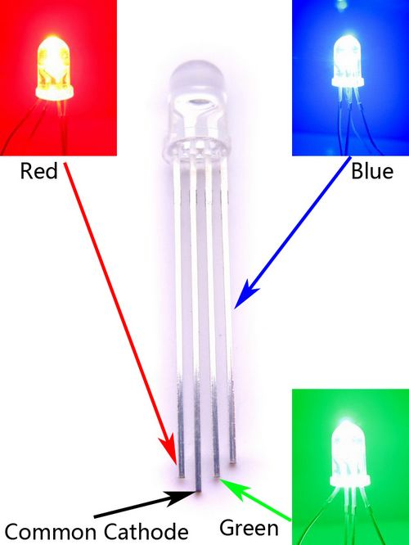

1. **BREAD BOARD:**

 A thin plastic board used to hold electronic components (transistors, resistors, chips, etc.) that are wired together. Used to develop prototypes of electronic circuits.

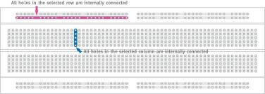

FUTURE SCOPE

Futurescopeforthehomeautomationsystemsinvolvesmakinghomesevensmarter.Homescanbe interfacedwithsensorsincludingmotionsensors,lightsensorsandtemperaturesensorsandprovide automatedtogglingofdevicesbasedonconditions.Moreenergycanbeconservedbyensuring occupationofthehousebeforeturningondevicesandcheckingbrightnessandturningofflightsif notnecessary.Thesystemcanbeintegratedcloselywithhomesecuritysolutionstoallowgreater controlandsafetyforhomeowners.Thenextstepwouldbetoextendthissystemtoautomatea largescaleenvironment,suchasofficesandfactories.HomeAutomationoffersaglobalstandardfor interoperableproducts.Standardizationenablessmarthomesthatcancontrolappliances,lighting, environment,energymanagementandsecurityaswellastheexpandabilitytoconnectwithother networks.